NEILPRYDE BALTIC CUP 2009

1. EVENT.
  - Neilpryde Windsurfing Baltic Cup 2009 in Latvia will take place from Saturday June 27th, to Sunday, June 28th 2009 in city Liepaja.
  - The 2009 Formula Windsurfing Baltic Cup Series- will be held :
1.1.1 Lithuania, 29th May - 30th May.
1.1.2 Latvia, Liepaja, 27th - 28th June.
1.1.3 Finland, 24 th - 27 th July.
1.1.4 Estonia, 28th – 30th August.

1.3 Each event in the Series is Level 3 Formula Windsurfing World Ranking event.

2. ORGANISER AND SPONSORS.
2.1 Neilpryde Windsurfing Baltic Cup 2009 in Latvia is organized by sports organization “Extreme Sports”, affiliated by : IWA, ISAF, Latvian Yachting Union.
The regatta is sponsored by :
● Neil Pryde International,
● Extreme Sports,
● Windsurfing club Rietumkrasts.
3. VENUE.
3.1 The event will be based in Liepaja city, at the Kara osta (Military port Liepaja) Windsurfing club ’’Rietumkrasts’’.

4. RULES.
4.1 This is an IWA / IFWC sanctioned series governed by:
4.1.1 The 2009/2012 ISAF Racing Rules of Sailing –Windsurfing Competition Rules (WCR) ;
4.1.2 The IFWC Class Rules & Championship Rules;
4.1.3 This Notice of Race ("NoR") & the Sailing Instructions (SIs);
  - Competitors shall attend the opening & closing ceremonies including the prize giving.
  - ISAF Regulation 20 - Advertising Code – applies.

5. ELIGIBILITY & DISCIPLINE.
5.1 All entries shall meet the requirements of ISAF Regulation 19-Eligibility Code.
5.2 A minimum of 3 races is required for a valid event in the series.
5.3 Competitors shall possess valid third party liability insurance.
5.4 Neilpryde Windsurfing Baltic Cup 2009 in Latvia is a single discipline. (Formula Windsurfing) regatta and Raceboard Class.
5.5 The regatta will give points to the annual BALTIC CUP 2009 final ranking list in Formula Class.

6. CLASSES, FLEETS & DIVISIONS.
Formula:
6.1 The regatta is “open entry” event for male & female competitors.
6.2 The divisions [Youth [U20], Junior [U17], Masters, Grand Masters shall race in the men’s fleet.
6.3 There may be separate prizes or trophies for Youth [U20], Junior [U17], and Masters divisions.
6.4 The position of the competitor within the division will be calculated from his/her position in the fleet results. No separate division scoring will be applied.
Raceboard :
6.5. There will be Raceboard class division with a separate start from Formula, for men and women.
RSX Olympic Board :
6.6. In Raceboard class division, there will be Olympic RSX class award for the best man and woman.
Techno 293 Class :
6.7. There will be a Techno 293 class division. It will start together with a Raceboard class, or separately.
6.8. There will be separate prizes or trophies for Junior [U15] and Junior [U17].

7. DIVISIONS.
7.1 Gender Formula class :
A- Men; B-Women;
  - Age:
Overall All competitors.
Women All female competitors.
Master A man who has reached the age of 35 (born 1973 and earlier), or a woman who has reached the age 30 (born 1978 or earlier) by
December 31st before the year of competition.
Youth U20 A man or a woman who is less than 20 years old by December 31st in the year of competition (born 1990 and later).
Junior U17 A man or a woman who is less than 17 years old by December 31st .
in the year of competition (born 1993 and later).
Junior U15 A man or a woman who is less than 15 years old by December 31st .
in the year of competition (born 1995 and later).
A Grand Master is a man who has reached the age of 45 (1963>).
  - A competitor must have reached the minimum age limit, in the relevant division, by Dec. 31st 2009.
7.9 A competitor must not be older than the maximum age limit, in the relevant division, by Dec. 31st2009.
7.10 A minimum of 5 entries is required to constitute a 'class' or a division within a class.

8. EQUIPMENT.
8.1 All competitors shall bring their own equipment.

9. EQUIPMENT INSPECTION.
9.1 It is the responsibility of each competitor to ensure that his/her board and equipment conforms to the Class Rules.
9.2 The Equipment Inspectors will pay special attention to sail identification rule compliance.
9.3 Equipment checks may be made throughout the event.

10. SAIL INSIGNIAS.
10.1 National letters & sail numbers shall comply with IFWC Championship Rule # 7.6

11. BUOYANCY.
11.1 If personal buoyancy is prescribed, every competitor shall wear a
personal flotation device that shall conform to the minimum standard
ISO 12402-5 (Level 50). Alternative or additional standards may be
prescribed in the Sailing Instructions.
11.2 All competitors aged 16 years or younger shall wear personal buoyancy.

12. LIABILITY.
12.1 Competitors take part in all races at their own risk.
The organizers; Extreme Sports, Neilpryde, Latvian Yachting Union, ISAF, IWA, IFWC, IFCA or any of their officials or representatives, or the sponsors, or their officials or representatives are not responsible, under any circumstances, for any damage, loss or injury either ashore or on the water either to persons or equipment, which may result.
Participation in this event, supporting events and in each race in them is at the sole discretion of the sailor and at his/her own risk. Notice is drawn to RRS 4.
Competitors shall possess valid third party liability insurance covering personal injury or equipment damage and carry evidence of such.

13. COURSES.
13.1 Courses shall be as prescribed in the SI’s; or published on the ONB.

14. SCORING.
14.1 Scoring shall comply with IFWC Championship Rule # 13.

15. PROTEST COMMITTEE.
15.1 An independent protest committee will handle the protests.

16. SAILING INSTRUCTIONS (SI)/EVENT PROGRAMME.
16.1 The 'Championship SIs' will be available at registration as will the Event Programme scheduling social events.
16.2 There could be made changes in Notice of Race and Sailing Instruction by Organizing or/and Racing Committee. It should be published at the Official Notice Board no later then 1 hour before the next possible start.

17. COACHES.
17.1 Coaches shall wear buoyancy aids when afloat.

18. SCHEDULE

Friday, June 26th:
12.00 – 21.00 Arrival, rigging, training.

Saturday, June 27th:
9.00 – 10.00 Registration.
10:30 Skippers meeting.
11:00 First possible start .

Sunday, June 28th:
9:30 Skippers meeting.
10:00 First possible start.
16:00 Last possible start.
Prize giving Ceremony.
Derigging, departure.

19. MEDALS AND PRIZES.
19.1 Awards may be awarded up to the first 3 Men/Women in each Class/Division depending on entry numbers. Prize categories and the actual number of prizes to be awarded in each properly constituted division will be posted on the official notice board after the close of registration and before the first race.
19.2 The First Man/ Woman shall be known as the Formula Baltic Cup Latvia Champion.
19.3 The First Boy/ Girl in the Youth Division shall be known as the Formula Baltic Cup Latvia Champion Youth.
19.4 The First Man/ Woman in the Masters Division shall be known as Formula Baltic Cup Latvia Masters Champion.
19.5 The First Boy/Girl in Bic Techno, Raceboard and RSX Division shall be known as Baltic Cup Latvia Champion.

20. DRUGTESTING.
20.1 Competitors are reminded of the ISAF rules and regulations concerning the use of banned methods and substances. Drug testing may take place during the event.

21. TELEVISION AND MEDIA.
21.1 In registering for the event, competitors automatically grant to the Organising Authority the right in perpetuity to make, use and show from time to time at their discretion, any motion pictures, still pictures and live, taped or filmed television and other reproduction of them, taken during the period of the event, for the said Championship as defined in the Notice of Race and Sailing Instructions in which he/she participates without compensation.

22. BIBS/VESTS & COMPETITORS SAIL BRANDING.
22.1 During racing, competitors may be required by the organizers to wear sponsors' branding sail stickers above the boom. Prior to arrival on site, competitors wishing to apply their own sponsor's branding to their sails below the boom are advised to seek 'brand approval' from the organizer to ensure that there is no conflict with event sponsors. The decision of the organizer will be final. Sponsor’s sail stickers are obligatory.
23. DRESS CODE.
23.1 Casual clothes shall be worn for the Opening Ceremony and Prize Giving Ceremony.
23.2 The organisers reserve the right to refuse entry to anyone whose standard of attire is not commensurate with the occasion.

24. ACCOMMODATION / TOURIST INFORMATION.
24.1 Book accommodation directly with the hotels or apartments. www.liepaja.lv

25. TRAVEL.
See additional information for travelling to Liepaja.

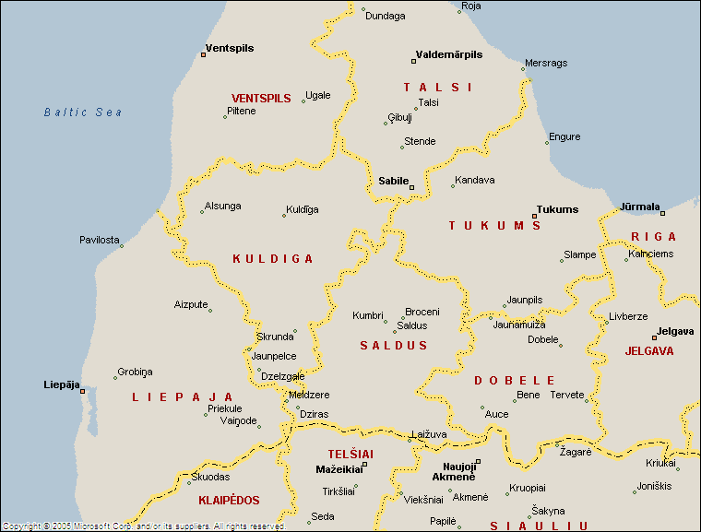

25.1 Event place in Liepaja GPS coordination in Google maps are 56.553581, 20.999422 / Karosta windsurfing club "Rietumkrasts"‎
http://maps.google.com/maps?f=q&source=s_q&hl=lv&geocode=&q=windsurfing+club+Rietumkrasts&sll=56.555332,20.999765&sspn=0.005487,0.019226&ie=UTF8&cd=1&ei=wk4uSpHnFMqksAagm6n2DQ&sig2=hg9WGmP7kasxQmysA3AoBg&cid=56553801,20999090,12278733896321000931&li=lmd&ll=56.556952,20.999079&spn=0.01114,0.032487&z=15

26. REGISTRATION.
26.1 The entry fee for the Windsurfing Baltic Cup Latvia is 20 Lats, for Youth and Bic Techno classes 10 Lats.
Each competitor shall personally register and sign the registration form and pay the entry fee at the Regatta Office before 10.00 AM on Saturday, June 27, 2009.
Late entry fee, after 10.00 AM on June 27, 2009 may be accepted. The fee will be 25 Lats for Men and Woman and 15 Lats for Youth.
26.2 Competitors will be required to produce the following registration formalities:
● Original Entry Form.
● Evidence of valid third party insurance.
● Proof of age.

27. ENTRIES & PAYMENT
27.1 The entry fee for the Windsurfing Baltic Cup Latvia is 20 Lats. Youth competitors pay 10 Lats. Exchange rate is 1 Euro = 0,7 Lats.
27.2 Entry fees paid on site shall be made in Lats only. No credit Cards, cheques or other currencies will be accepted.

28. OFFICIAL EVENT WEBSITE
Daily news, pictures and results:
www.formulawindsurfing.org

29. REGATTA OFFICE/INFORMATION
Events official website:
www.formulawindsurfing.org
Phone - +371 29456080, Mr. Juris Vasioleks.
Phone- +371 29216040, Mr. Ansis Dale

