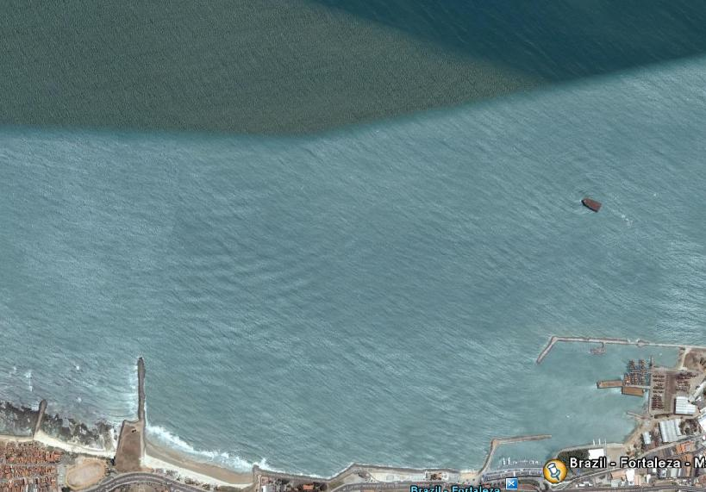
COURSE DIAGRAM 30/11/2008

WIND

` START gate 2 gate 1

FINISH

COURSE: START – gate 1 – gate 2 – gate 1 – gate 2 - gate 1 – FINISH
All distances and angles are approximate
Start line: CR flag on signal boat and flag on pin-end mark - Finish line: flag on Pier and flag on finish mark

