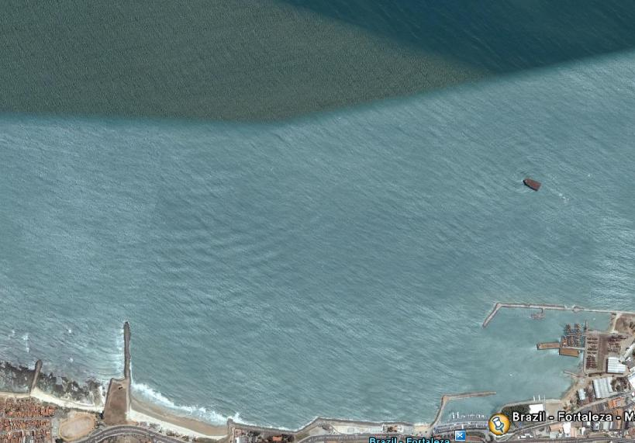
COURSE DIAGRAM 28/11/2008

WIND

G1

` 2 START 1

G2

FINISH

COURSE: START – 1! – 2 – gate – 1! – 2 – gate – 1! - FINISH
All distances and angles are approximate
Start line: CR flag on signal boat and flag on pin-end mark - Finish line: Blue flag on Pier and flag on finish mark

