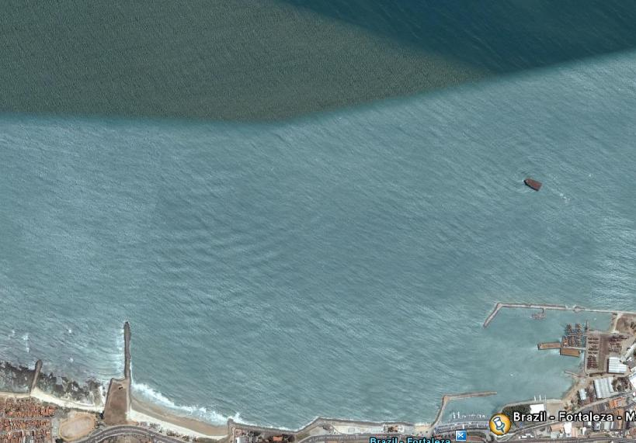
COURSE DIAGRAM 26/11/2008

WIND

START 2 1

FINISH

COURSE: START – 1! - 1b– 2 – 1! – 1b – 2 – 1! – 1b - FINISH
All distances and angles are approximate
Start line: CR flag on signal boat and flag on pin-end mark - Finish line: Blue flag on Pier and flag on finish mark

