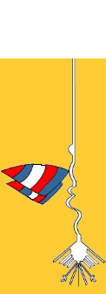
Asociación Peruana de Windsurf

WORLD CHAMPIONSHIP 2008 - PERU

FORMULA EXPERIENCE WORLD CHAMPIONSHIP
FORMULA WINDSURFING YOUTH WORLD CHAMPIONSHIP
FORMULA WINDSURFING MASTER WORLD CHAMPIONSHIP

ABOUT PERU:

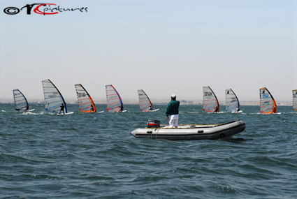

Peru is one of the first countries in the world racing Formula Experience. We had our first Formula Experience event early in 2002 and already organized late 2002 the first South American Formula Experience championship. Considerable group of Peruvians have participated in FE World championship events in 2005 (USA) and 2006 (Belgium).
Actually, our local FE fleet have about 40 racers, starting from kids of 11 years old. We expect to get to the event with about 60 local racers.
Paracas, the spot selected for the event have the ideal conditions for a Formula event, flat water, no waves and wind all days from 15-25 knots in December. Also, is summer so water temperature is over 20 Celcius degrees always and maximum air temperature can reach 30 Celcius degrees.

Paracas is also a great place for tourism, with lots of natural life, and really nice places to visit. Very close we can find Ballestas Islands (to visit by boat) and Nazca Lines (to visit by air). Also, for the freestyle guns, Paracas is one of the best places, and also, near the event site, are located some very good wavesailing spots. Finally, we strongly recommend to visit Machu Picchu, one of the new 7 wonders of the world that is really easy to access by airplane from Lima.

The Peruvian Windsurfing Association and Peruvian Windsurfers invite you to visit an exotic country, that will be for sure, a really different experience for all competitors and families. For sure, for New Years, our local team will prepare a great party to share with our guests.

1. Event
The Formula Experience World Championships and Formula Windsurfing Youth & Masters World Championship will be held from December 27th 2008– January 3rd 2009 in Paracas, Ica, Perú.

2. Organizer
The event will be organized by the Peruvian Windsurfing Association, for and on behalf of ISAF, and under specified conditions laid down by the the Formula Experience Class Association and IWA.

3. Venue
The racing will take place in Paracas bay, that is actually one of the best spots for racing in the world. During December the weather conditions are usual 15-25 knots, water temp 19-23°C, average air temp during the day 23-30°C and 19-23°C during the night.
Paracas has a really stable climate and wind is expected usually all days from 1pm to 6pm. There is no waves so access in the beach is really easy and the chop can be flat to medium chop depending on the wind conditions.

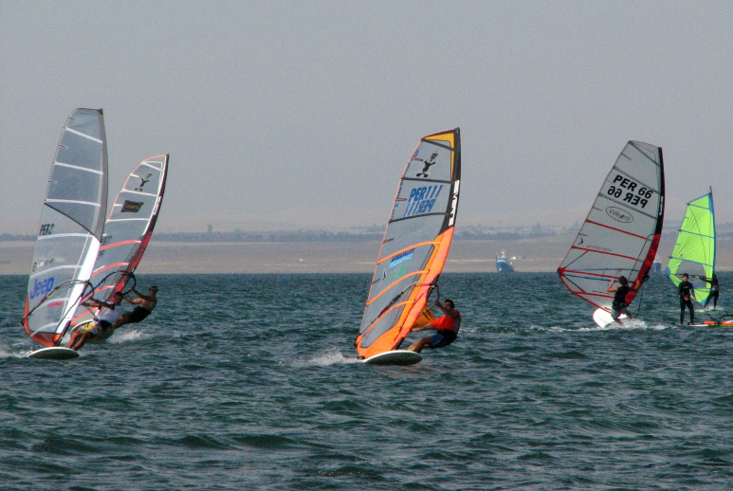
Good wind conditions in Paracas, Peru

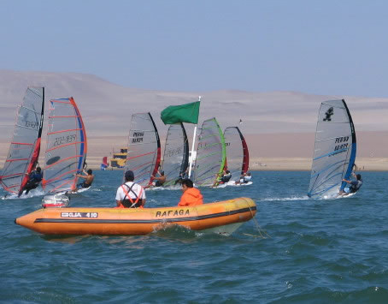
Picture taken during an FE event in Paracas

4. Eligibility and Discipline

A minimum of 3 races is required for a valid championship.

The World Championship is open to all sailors, subject to approval of the national member association, if any*, in the following divisions:

* In countries where a national selection system is in force or other selection criteria or requirements for international competition apply, the FE member national association must give prior approval.

• Juniors Boys & Girls (7.5m2)
• Juniors Boys & Girls (8.5m2)
• Youth Boys & Girls (11m2)
• Senior Men (12 .5m2 + fe 11m2 division) & Women (11 m2 )
• Masters Men (12.5m2 + fe 11m2 div.) & Women (11m2)
• Grand Masters(12.5m2 + fe 11m2 div.) Men & Women (11m2)

5. Championships
There is a maximum of 15 races scheduled during the event.

6. General
A minimum of 5 entries is required to constitute a "fleet" or a division within a fleet.

7. Courses
Courses will be specified in the Sailing Instructions and on the Official Notice Board.

8. Schedule

The detailed schedule will be detailed soon in this notice of race. Anyway, the organizers have scheduled a draft of this one as follows.

December 27th: Registration and racing for fun (not qualifying yet for the event).
December 28th: First day of racing
December 29th: Second day of racing
December 30th: Third day of racing
December 31st: Fourth day of racing. New years windsurfers party (dinner and dancing party) in the night for all competitors.
January 1st: Free day for resting or tourism.
January 2nd: Fifth day of racing
January 3rd: Sixth day of racing. Closing ceremony.

9. International Jury
An International Jury will be appointed. Their decisions will be final and cannot be appealed.

10. Sailing Instructions (SI's) / Event Program
The SI's will be available at registration as will the event program, which will outline the schedule for social events, clinics, etc.

11. Accommodations
Paracas is a Natural Reserve that have hotels and hostels to stay and several lodgings and bungalows to rent. We would present a detailed list of places to make reservations.
For sure, there are places to rooms in front of the competitors so can be really easy to have complete access to the beach from your hotel.

12. Air Travel/Transportation
The nearest international Airport is located in LIMA, the capital of Perú. Paracas is located 3 hours by car from the airport and the organizers will give free transport for non-Peruvians on December 26th and 27th, as in January 4th and 5th.
Please notify the organizer of your requirements and your flight details on time.

For more local Information before the regatta and to make enquiries please contact :

Peruvian Windsurfing Association www.windsurfperu.net
Event organized with the support of Club de Regatas Lima

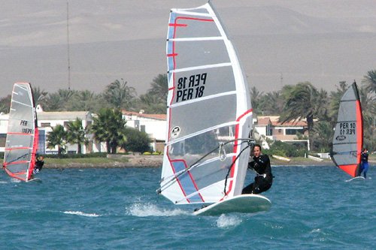
Paracas bay, plenty of houses and lodging to rent

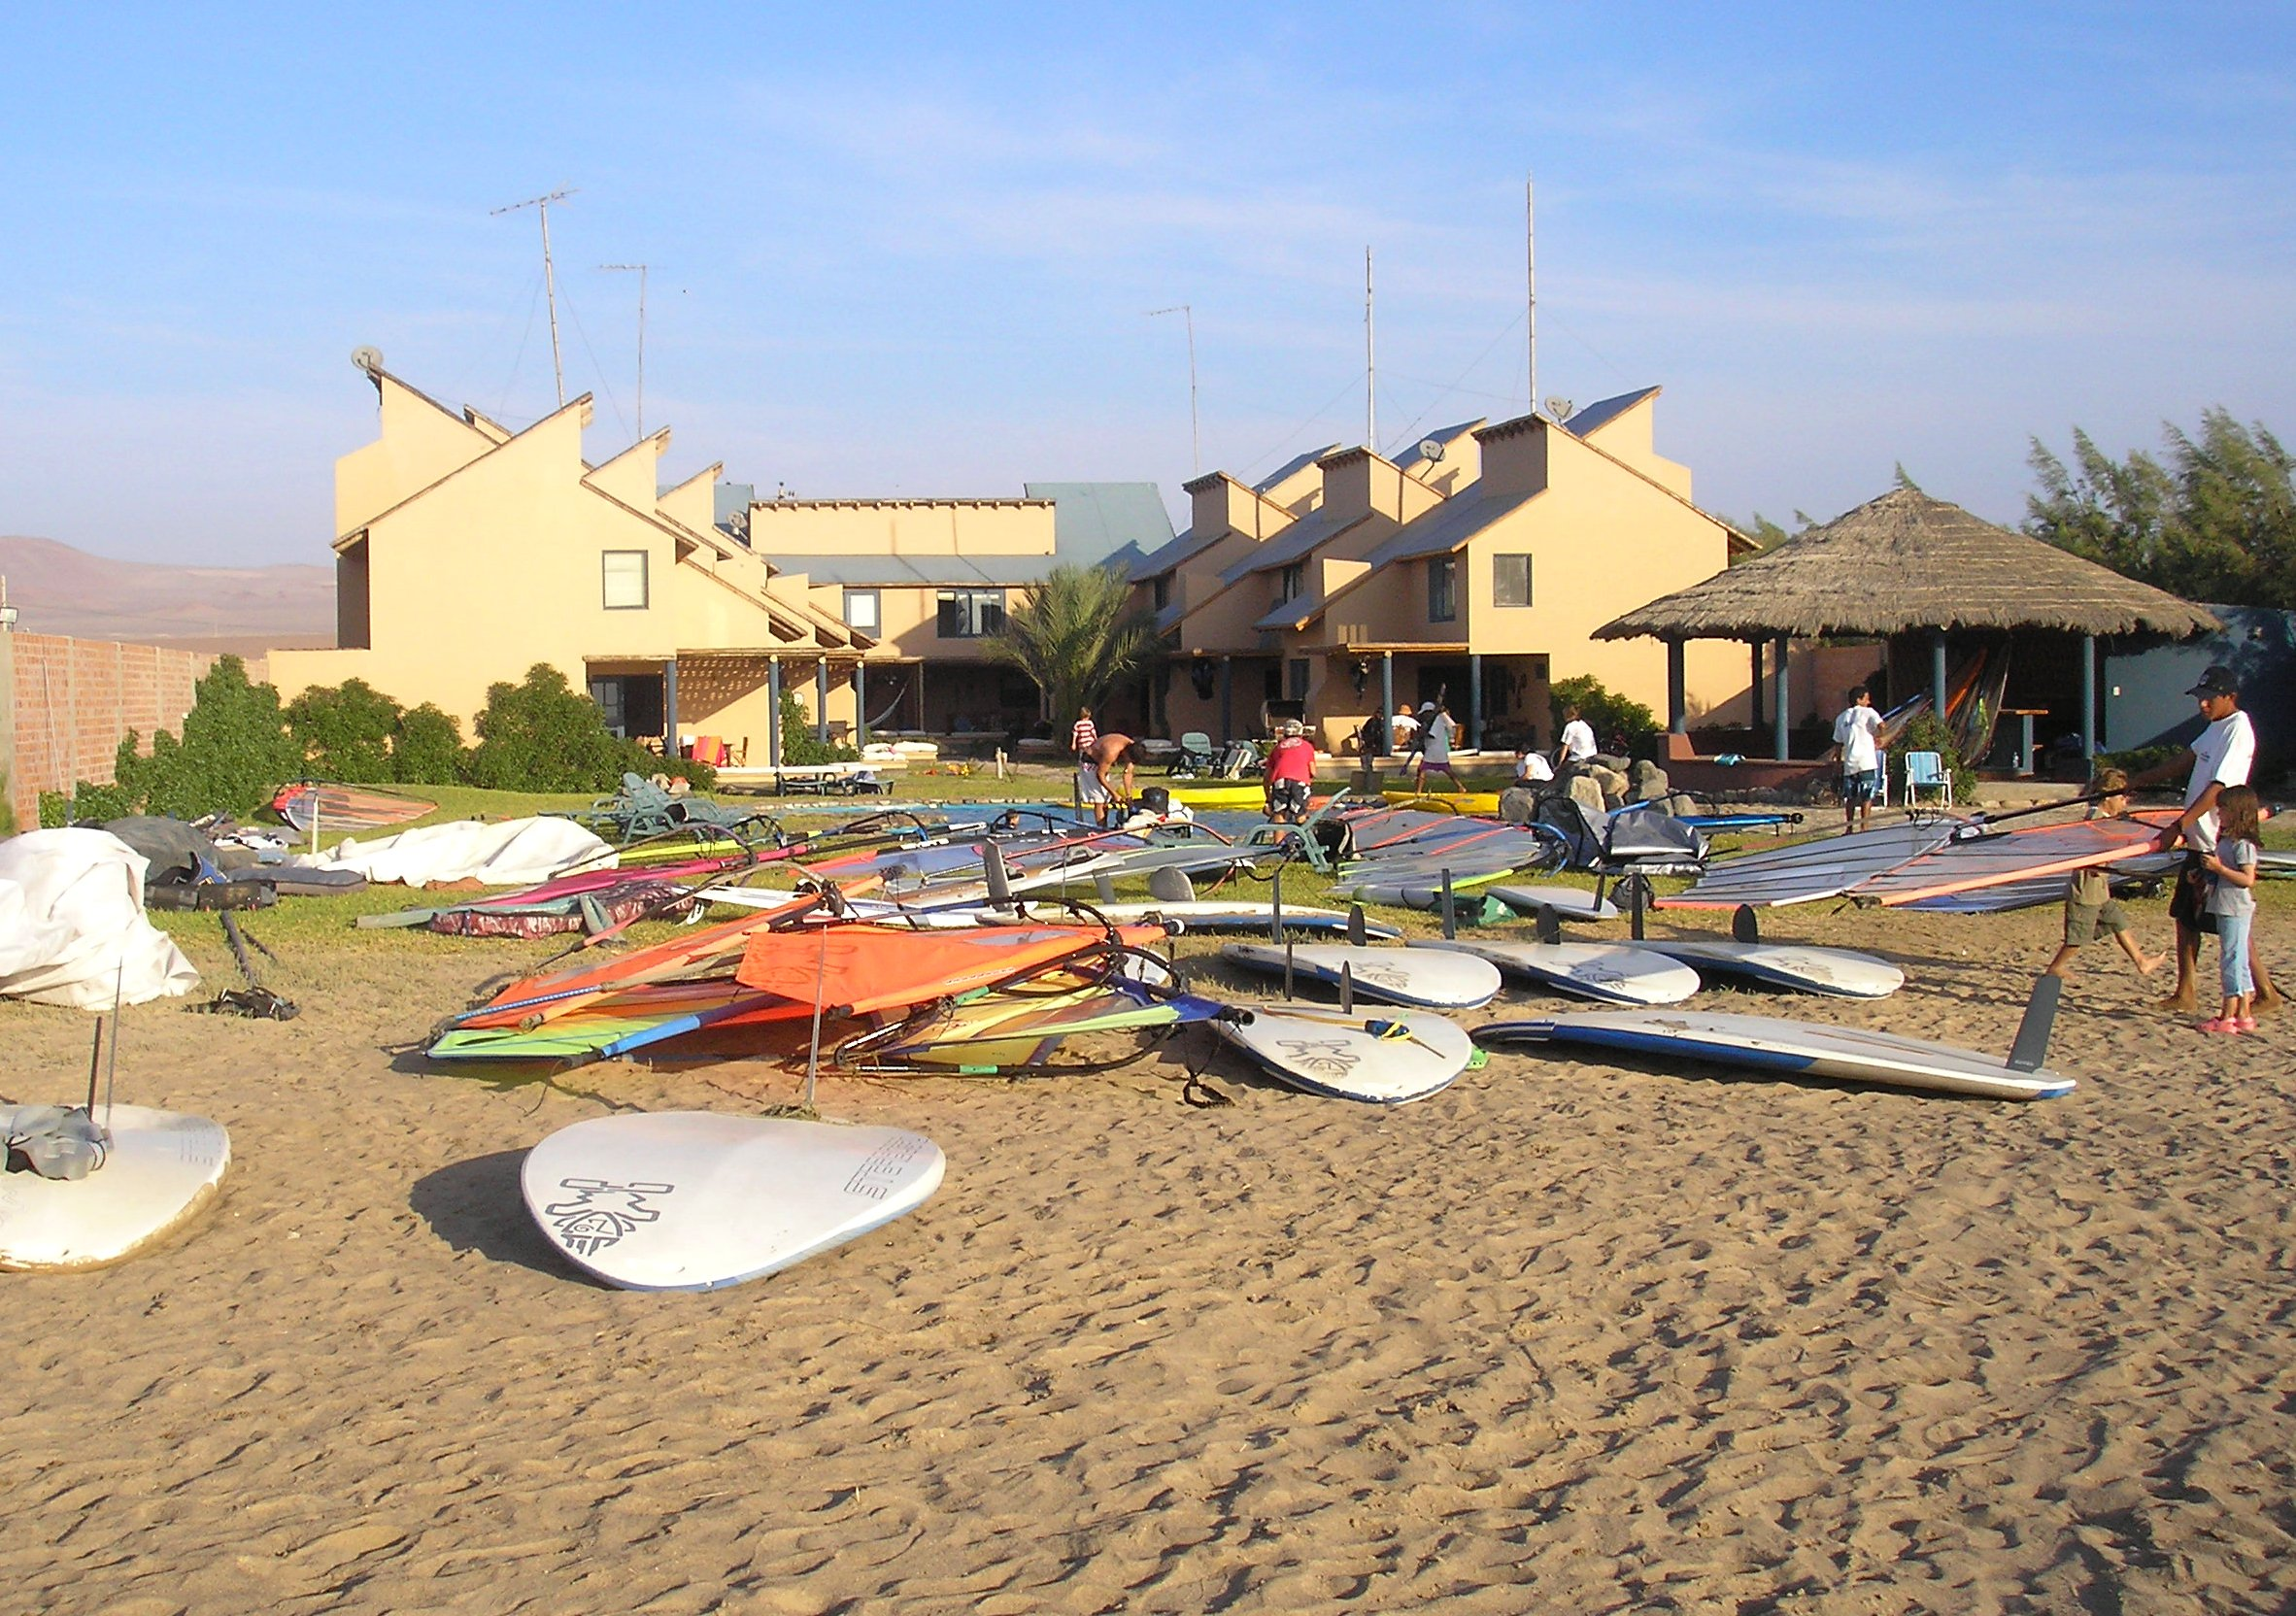
Bungalows beach front

