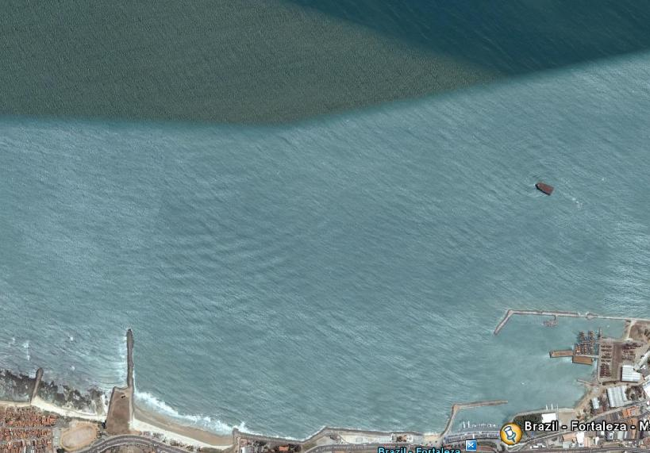
COURSE DIAGRAM 3/12
START 2 1
FINISH

COURSE: START – gate 1 – gate 2 – gate 1 – gate 2 - FINISH
All distances and angles are approximate
Start line: CR flag on signal boat and red mark S1, Finish line: Blue flag on pier boat and red mark

