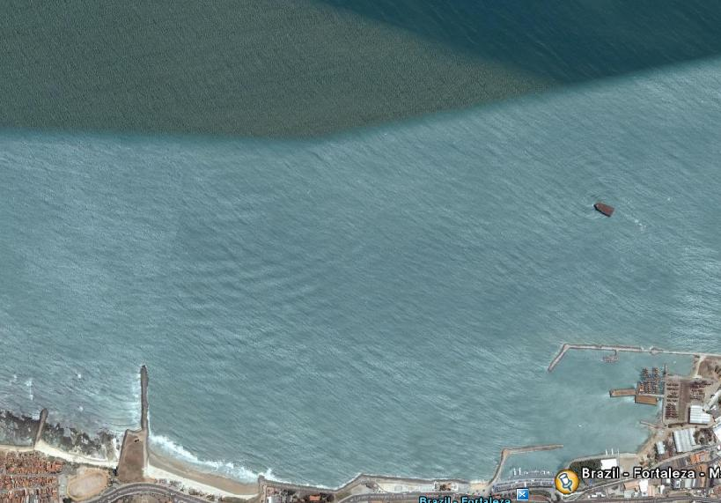
COURSE DIAGRAM 30/11

WIND

3 START 1

2 FINISH

COURSE: START – 1 – 2 – 3 – 1 – 2 – 3 – FINISH
All distances and angles are approximate
Start line: CR flag on signal boat and red mark - Finish line: Blue flag on Pier and mark 2

