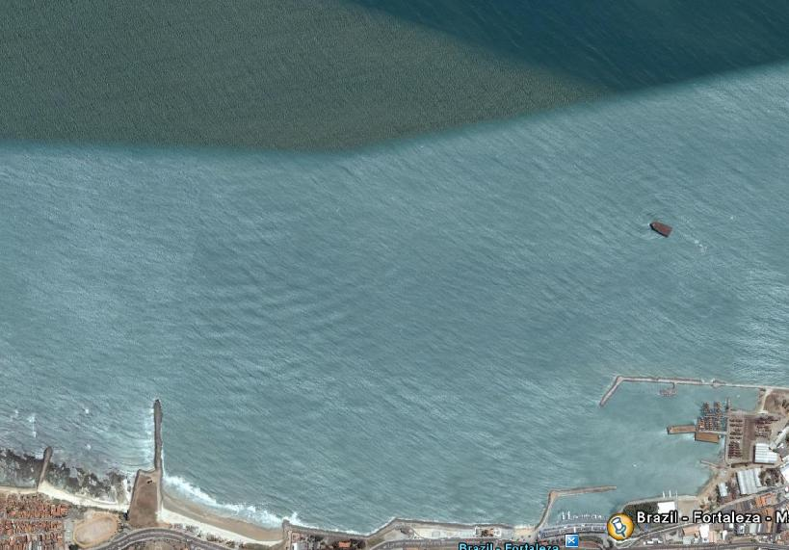
COURSE DIAGRAM 29/11

WIND

START 2 1

FINISH

COURSE: START – 1 – 2 – 1 – 2 – FINISH
All distances and angles are approximate
Start line: CR flag on signal boat and red mark - Finish line: Blue flag on Pier and red mark

