International
FORMULA WINDSURFING
2005 CHAMPIONSHIP RULES



1 GENERAL
  - Location
FW Worlds shall be within 200km of an
International airport, and easily reachable by car.
  - Gender Divisions
    - MEN (A)
    - WOMEN (B)
  - Age Divisions
    - YOUTH (C) is a man or woman who is less that
20 years old ;
    - Junior (D) is a boy or girl who is less than 17 years old :
    - Master (G) is a man who has reached the age 35 , or a woman who has reached the age of 30 ;
    - Grand Master (H) is a man who has reached the age of 45 , or a woman who has reached the age of 40 .
    - A sailor must have reached the minimum age limit in the relevant age division by December 31st before the year of competition .
    - A sailor must not be older than the maximum age limit in the relevant age division by December 31st in the year of competition.
  - Weight Divisions
    - Lightweight -A sailor who weighs less than 80kg ;
    - Heavyweight- A sailor who weighs more than 75kg .
  - Division Identification
At events where the organising authority specifies the use of identification of divisions, the identification shall be displayed on the top panel of the sail , and be a minimum of 230mm in height .
WOMEN red diamond
MEN HEAVY black circle
MEN LIGHT black semi circle
YOUTH black triangle
JUNIOR black open triangle
1.6 Minimums
A minimum of 5 entries is required to constitute a division .
1.7 Pumping
If pumping becomes the main method of propulsion
the race shall be abandoned .

2. NUMBER OF RACES; TIME LIMITS; TARGET TIMES; REST PERIODS; WIND SPEEDS
2.1 NUMBER OF RACES
    - No more than four races per day per fleet shall be scheduled or raced (3 for juniors)
    - The maximum of races that can be scheduled in a Series (or a First Round and a Final Round) is 15 (12 for juniors).
    - 3 races shall be completed by a class or division to validate a championship or event for that class or division.
2.2 WIND SPEEDS
2.2.1 If the wind speed is less than 7 knots in the
starting area at any time during the last minute
prior to the starting signal, the start shall be
abandoned .
2.2.2 Wind speeds shall be taken from a drifting boat
from approximately 2 metres above the sea
surface.
2.2.3 The Race Officer shall ensure that the wind is
measured over as much of the course area as
possible .
2.2.4 Racing shall take place in suitable conditions, and
the decision on suitable conditions shall be made
by the Race Officer , and where appropriate the
Class Race Supervisor .

2.3 TIME LIMITS & TARGET TIMES
2.3.1 The time limit for the first finisher in a course race
is 40 minutes
2.3.2 The time limit for the first racer in each division to
reach the first mark is 12 minutes.
2.3.3 A race shall be abandoned if either of these time
limits ( above) is exceeded and anyway shall not
count towards the official results.
2.3.4 Racers finishing more than 15 minutes after the
first finisher in their respective division shall be
scored DNF except those who are scored DSQ,
BFD, OCS, RAF, RDG, DGM or DNE.
2.3.5 The target elapsed time for a course race in
planing conditions is 15>20 minutes for the
winner.
2.4 REST PERIODS
2.4.1 When racing back to back, the minimum interval between the closing of the finishing line and the new warning signal for that fleet/division shall be a minimum of 10 minutes.
2.4.2 Except in a regatta scheduled to last 4 days or less, a class/group shall be sent ashore when it has sailed two races back to back to enable the last finisher in the second race to have a rest period of a minimum of 20 minutes, before the warning signal for the third race for that fleet/division. When a regatta is scheduled for 4 days or less, a maximum of 3 races may be sailed back to back.

- PERSONAL BUOYANCY
  - If personal buoyancy is prescribed every sailor
shall wear above the waist a jacket or vest with a
minimum buoyancy of 4kg in fresh water. The
buoyancy shall be tested with a metal weight of 4kg
which shall remain supported for a minimum of 5
minutes.
  - Personal buoyancy shall not weigh more than 1.5kg
when wet weighed in accordance with RRS
Appendix H.

4 CHANGING RIGS
When changing rigs, a racer shall return to the beach from which he/she launched to obtain the new rig. Caddies are not permitted.

5 SUPPLIED EQUIPMENT
When the equipment is supplied for an event by the organising authority, the notice of race shall state which items of equipment shall be supplied including the number and type/size of footstraps, fins and rigs.

6. EQUIPMENT REGISTRATION & CHECKS
6.1 Each racer shall complete one Equipment Registration Form obtained from the registration desk and return it before the close of registration.
6.2 Each racer shall clearly identify each fin that he/she intends to use during racing at the regatta with a unique serial number, which shall be listed on his/her Equipment Registration Form against the size, brand and model name of the fin concerned. This process shall be completed before the close of registration.
6.3 Each racer shall clearly identify each sail, which he/she intends to use during racing at the regatta with an event sail tag (or as specified in the Notice of Race and Sailing Instruction,) which shall be securely fixed to the clew. The serial number of each tag shall be listed on the Equipment Registration Form against the size, brand and model name of the sail concerned. This process shall be completed before the close of registration.
6.4 Each racer shall list the serial number of the board that he/she intends to use during racing at the regatta on the Equipment Registration Form. This process shall be completed before the close of registration

6.5 EQUIPMENT CHECKS & MEASUREMENT
6.5.1 The Equipment Inspectors may check and
measure equipment, at any time during the regatta.
6.5.2 After finishing the race, identified racers, at sea, shall immediately sail to the beach, and await the Inspectors’s instructions.
6.5.3 Racers identified as they reach the beach shall follow the Inspectors’s instructions.
6.5.4 Until the Inspector gives permission, a selected racer and his/her equipment shall have no contact with a coach or support personnel.
6.5.5 A racer, so notified, shall not leave inspection area, without the permission of the Inspectors. Failure to comply may result in disqualification.

7. SAIL INSIGNIAS
7.1 National letters & sail numbers shall be in a colour contrasting strongly with the body of the sail placed immediately above the event advertising.
7.2 National letters & sail numbers shall be clearly legible . All Sails shall otherwise comply with the national letter system according to the RRS 77 & Appendix G , as amended by Appendix B.
7.2 National letters & sail numbers may alternatively be placed back to back on an opaque white background. Otherwise they shall comply with Art #7.1 and 7.2 .

8. EVENT SPONSOR’S ADVERTISING
8.1 In the event that racers are required to carry advertising in compliance with ISAF Regulation 20-Advertising Code - Art #20.3.(d) (ii), the maximum size of the event-advertising sticker is 1 sq. metre.
8.2 In such a case…
- each racer shall place the advertising stickers issued by the organising authority, back to back immediately above the boom and as close to the leach as possible.
b) Racers shall not cut or adapt the stickers in any way.
c) Lycra vests issued by the local organiser shall be worn outside other clothing when going afloat to race or racing.
d) Only event advertising stickers and/or Lycra vests issued by the local organiser of the regatta in which the racer is currently entered may be worn or appear on the sail.
8.3 The local organising authority (LOA) may also require the first, second and third racer overall in the men’s and women’s classes to wear coloured Lycra vests and carry self-adhesive identifying disks on their sails. The colours used shall be yellow, blue and red respectively. In such a case,
a) The racers affected shall comply with Art#8.2(c) above;
b) And fix the disks just above the sail number on their sails, whilst racing.
c) A racer shall not carry or wear such identification when he/she no longer occupies first, second or third place.
d) The LOA will post a notice on the official notice racer stating where and when racers shall collect this identification in the morning and where to return it to after racing each day.

9. RACING FORMAT
9.1 FLEET SIZES
9.1.1 The maximum fleet size shall be 120.

9.2 SEEDING LIST, FLEET OR GROUP RACING
9.2.1 Where there are 70 or fewer racers entered in a class/division, they shall race together in one fleet.
9.2.2 Where there are between 71 and 90 racers entered in a class/division, the Class Race Supervisor shall decide whether they shall race in one fleet or whether there shall be a First Round followed by a Final Round.
9.2.3 Where there are more than 90 racers entered in a class/division, they shall race a First Round followed by a Final Round. They shall be divided into two Groups of approximately equal ability, according to current Formula Ranking.
9.2.4 The racer heading the ranking list shall initially be in the first Group, racers in 2nd and 3rd positions on the ranking list shall be in the second Group, racers in 4th and 5th positions on the ranking list shall be in the First Group and so on.
9.2.5 The first Group shall be designated the Yellow Group and the second the Blue Group.
9.2.6 The Blue Group (silver fleet) shall carry a blue ribbon provided by the local organiser tied to the batten-retaining strap of the second batten above the boom. The LOA will post a notice stating where and when these ribbons will be issued before the first race of the day.
9.2.7 The decision of the Class Race Supervisor is final.

9.3 FIRST ROUND
9.3.1 The First Round may be held over three days.
9.3.2 When, at the end of each day, the two Groups have completed an equal number of races, they shall be intermixed according to their current standing. At other times they may be intermixed according to their current standing provided that each Group has completed the same number of races.
9.3.3 If, at the close of racing on the third day of the First Round, six races have not been completed by each of the two Groups, racing will be held on succeeding days until the minimum number of six races has been completed.
9.3.4 The first round shall consist of no more than 8 races.

9.4 OVERALL STANDING
At the end of the First Round, an overall standing will be established. A boards overall standing shall be the sum of her scores for all first round races excluding their worst score in accordance with RRR Appendix B, #B8.2. If racing in the Final Round is not possible, this shall count as the official result. The competitor with the lowest score will head the overall standing.

9.5 FINAL ROUND
Racing in the Final Round will take place in the Gold and Silver Fleets. The Gold Fleet shall consist of the top 50% of racers based on the Overall Standings (Art # 9.4) plus one in the case of an odd number of entries. In case of ties at the break point those racers so tied shall sail in the Gold Fleet. The fleet lists shall be posted at least 1 hour before the first scheduled starting time of the first race of the Final Round
.
9.6 FLEET STANDING
A racer's fleet standing will be the sum of their scores for all races excluding their worst score(s) in accordance with RRS Appendix B # B8.2. The racer with the lowest total score will head the fleet standing. Silver Fleet racers will be ranked in the fleet standing after those in the Gold Fleet.

10 CHANGES TO THE SAILING INSTRUCTIONS
10.1 Any change in the sailing instructions will be posted, after approval by the Class Race Supervisor, on the official Notice Board before 0900hrs. on the day that it takes effect except that any change to the schedule of races will be posted before 2000hrs, on the day before it will take effect.
10.2 The course and racing area to be used will be posted on the official notice board one hour before the next race.

11 SIGNALS
11.1 Signals Made Ashore:
11.1.1 Signals made ashore will be displayed on the official flagpole located near to the launching area. When a “Racing Area” flag is displayed over a class/division/group flag, the “Racing Area” flag applies only to that class/division/group.
11.1.2 The following signals will be used:
- ICF AP (with two sound signals) means: “All races are postponed. Flag AP flown over a Class/division Flag means racing for that Class/division is postponed. The warning signal for a Class/division will be made not less 30 minutes after its AP flag is lowered (with one sound signal).”
- ICF L (with one sound signal) means:
“A notice to competitors has been posted.”
- ICF Y means: “Competitors, Coaches and support racer personnel shall wear their buoyancy vests.”
- ICF D means: “The safety system (see Art # 20.2) is in force”.
(The D flag will be hoisted not less than one hour before the next start )

11.2 Signals made afloat:
- ICF Y means:
a) When there is no ICF Y flag flown, each competitor supported by a coachboat may place his/her buoyancy vest is in his/her coachboat;
b) Coaches may take off their buoyancy vests
c) Racers may put their buoyancy vests in the Racer Support boat (Art# 24.5)
- ICF R means: “A rescue operation is in progress. Coachboats shall assist.”

12 RACING SCHEDULE
12.1 The Racing Schedule is as specified in the Notice of Race and notices to competitors.
12.2 In suitable conditions, racing shall be run back to back according to Art # 2.3. The warning signal for a subsequent race on the same day shall be made as soon as practicable. It may be preceded by a signaled postponement (ICF AP) of not less than 5 minutes.
12.3 The warning signal for the last race of each day shall not be made within 60 minutes of the official local sunset time.

13 RACING AREA
  - The racing area shall be shown as an appendix to the Sailing Instructions.

14. COURSES & COURSE AREAS
14.1 SELECTION OF COURSE TYPES
Recommended courses are included in Appendix 1 attached to these Championship Rules .
14.2 COURSE AREA(s)
14.2.1 The course area is defined as an area extending 75 metres beyond the course including the 'starting line' and the 'finishing line' and its extensions, which would normally be taken by a racer when racing.
14.2.2 Access to the course area during a race is restricted to racers racing and official boats as defined in Art#24.

15 THE START
  - Races shall be started according to RRS 26
System 1 .The Z flag shall not be used .
15.2 The interval between the "Starting Signal" of one class/division/group and the "Warning Signal" of the next division/fleet will be at the discretion of the Race Committee.

16. THE STARTING LINE
16.1 The Starting Line will be the line between the mast on the Race Committee vessel flying a flag corresponding to the colour of the “Racing Area” at the starboard end, and the course side of the pin-end buoy at the port-end.
16.2 A committee boat may be positioned on the extension of the starting line. This committee boat will fly a “Racing Area” flag.
16.2.1 During the last minute before the start, competitors shall not sail between the boat (Art # 16.2) & the pin-end buoy at the port-end.
16.3 If any part of a board ,sail or crew is on the course side of the starting line or its extensions during the minute before her starting signal , she shall thereafter sail from the course side across an extension to the pre start side before starting . ICF “I” will not be displayed .
16.4 A board shall not start later than 4 minutes after her starting signal .
16.5 When conditions are unfavourable, the starting line Race Committee vessels may hold position by using engines.

- RECALLS
  - Recalls shall be signaled in accordance with RRS
29.
17.2 When an individual recall has been signaled, the sail numbers of the identified competitors will only be posted on the Race Committee Vessel just before the finish of the race.
17.3 When a General recall has been signaled, the succeeding start(s) for the same and/or for different class(s)/group(s) will be given according to the flags hoisted on the "Race Committee Vessel".

18 THE FINISHING LINE
18.1 The "Finishing Line" will be between a mast flying the “Racing Area” flag on a Race Committee boat displaying a blue flag and buoy or a staff/mast positioned on the beach.
18.2 The position of the finishing line is shown on the relevant course diagram either attached to these rules or to the Sailing Instructions.
18.3 When conditions are unfavourable, the finishing line Race Committee boat(s) may hold position by using engines.

PROTESTS
19.1 RRS 61 shall apply.

19.2 Competitors taking a penalty shall complete the “Alternative Penalty Form” in the race office as soon as they come ashore but anyway by the end of “Protest Time” of their class/group on that day.
19.3 “Protest time” for each class/group, will end 45 minutes after the last racer has finished the last race of the day for that class/group. Protests time limits will be posted.
19.4 Notices informing the parties to the protest of the intended order and of the approximate time of the hearings will be posted on the Official Notice Board as soon as possible after the protest has been lodged (not later than 30 minutes after Protest Time). It is intended that protests will be heard in the approximate order of receipt and parties are requested to remain in the vicinity of the Jury Office to expedite hearings.
19.5 Protest hearings will be held in the Jury Room.
19.6 For the purpose of RRS 64.3(b), the qualified authority is the ISAF.
19.7 Competitors wishing to clarify a scoring enquiry shall initially do so by completing a “Scoring Enquiry Form” and by lodging it at the Regatta Office. Only if the response given by the Race Committee is unsatisfactory in the opinion of the competitor should he request a hearing under RRS 62.
19.8 Competitors wishing to retire from a race shall make a retirement declaration at the Regatta Office.
19.9 Re-opened hearings:
19.9.1 In the “First Round" requests to open a hearing under RRS 66 will not be accepted later than 15 minutes after the end of the last protest hearing in that "Round". (Alteration to RRS 66)
19.9.2 Other requests to open a hearing under RRS 66 will not be accepted later than 15 minutes after the end of the last protest hearing on the day of the last scheduled race. Any request for redress, lodged after jury hearings are completed for the regatta, will not affect the prize giving ceremony. (Alteration of RRS 66 )
19.10 Infringements of Art # 6, 20, 22, and 25 of the championship rules shall not be grounds for protest from one racer to another, but may result in action by the International Jury and/or Race Committee (Alternation of RRS 60).
19.11 RRS 69 also applies to any team member or official (Alternation of RRS 69).

20. SAFETY REGULATIONS
20.1 Abandoning:
20.1.1 A competitor that retires from a race shall, whenever possible, notify a Race Committee boat before leaving the course area. Notwithstanding such notification, she shall then proceed, as soon as possible, to the beach and the competitor shall immediately report to the Regatta Office, in person or, if the competitor has come ashore along way from the race site, by phoning the Regatta Office. Failure to comply with this instruction may result in action under RRS 60.2 or 60.3.
20.1.2 Competitors not leaving the site for the days racing shall inform the Beach Office prior to the first start.
20.2 Safety System:
20.2.1 The Safety System is in force when the ICF "D" is displayed on the "Official Flag Pole" as defined in the Event sailing Instructions
20.2.2 Sign-out/in sheets will be provided, by the Race Committee, outside the regatta office.
20.2.3 Each competitor, intending to race, shall personally sign-out, against his name/sail number, when going out to race.
20.2.4 When returning ashore each competitor shall personally sign in to confirm that he/she has returned to shore…..
a) ...Either within 30 minutes of the end of the time limit of that race, or in the case of back to back races, the last race of that class/division for the day ,
- ...Or, within 30 minutes after being instructed to go ashore by the Race Committee.
20.2.5 Alternative Safety Systems may be approved by
the Class Race Supervisor .Full details will be
published in the Sailing Instructions.

21 SCORING
21.1 Scoring shall be in accordance with RRS Appendix
A as amended by Appendix B , and using “Low Points Scoring System”.
21.2 Where there is more than one “Division” racing in a single fleet, competitors may score points equal to their finishing place in their “Division” in that race and Official Results will be published for each “Division”.
21.3 In Alteration of RRS Appendix A, racers without a finishing place, including a racer that finished and thereafter retires or is disqualified, will be scored points for the place one more than the number of racers entered…
i. In “Fleet Racing”, the number of competitors in that fleet.
ii. In a “Division” within a “Fleet”, the number of competitors in that “Division”.
iii. In the “Qualifying Round”, the number of competitors in the largest group of that “Round”;
iv. In the “Final Round”, the number of competitors in the “Gold Fleet.”
21.4 “Silver Fleet” Competitors will score points from "qualifying round" plus the number of points corresponding to Art#21.1 above in order to be ranked according to Art # 9.6

22. ELECTRONIC EQUIPMENT, COMPASSES & COMMUNICATION
22.1 Electronic equipment and compasses are prohibited with the exception of devices whose sole capability is timing.

23. SUPPORT CRAFT
23.1 Coach and support personnel may use "support craft" to assist their competitors on the water. They shall register at the regatta office prior to the first scheduled race, providing details of their boats and distinctive identification.
23.2 Except as provided by Art#23.3 below, all teams support craft shall conspicuously display the national flag of their country of origin (600 x 400mm minimum) or the national 3 letter code in black (minimum height 120mm) on a white background while afloat.
23.3 When a support craft is supporting competitors, from more than one nation and is registered as such, they shall be required to display only one national flag or national 3-letter code.
23.4 Before the Preparatory Signal of any class/division/group, support craft shall have left the course area (Art#14.2.1) and remain outside the area, except to assist a racer in distress, until after the finish of the last competitor of the final class/division/group racing on that area.
23.5 In the event of a postponement, support craft may re-enter the course area.
23.6 If a support craft fails to comply with a part of Art # 23.4 the registration shall be withdrawn and the support craft not permitted within the Race Area.

24. OFFICIAL BOATS
24.1 A Race Committee (RC) boat belonging to a particular Racing Area shall fly a flag corresponding to the colour of that Racing Area.
24.2 An RC “Mark boat” may be stationed beyond each mark. Failure of a mark boat to be on station or to display her signal shall not be grounds for redress.
24.3 Other Race Committee boats may include:
- The 'measurer's boat,' which will fly a white flag with the letter 'M' in black.
- The Jury boat, which will fly a white flag with the letter “J” in black.
- Rescue boats which will fly a Red flag with the letter “R” in black.
24.4 Media boats and helicopters are not under the direct control of the Race Committee. However, they are required to keep clear. Their failure to do so is grounds for redress, whether there is physical damage or not (Alteration or RRS 62.1)
a) Media boats are identified by a white flag with the letter “P” in black
b) Media helicopters are identified by a white self-adhesive sticker on each side with the letter “P” in black
24.5 One Racer support boat anchored approx. 75 metres below the Race Committee vessel on each course will be provided by the LOA for competitors to place their life jackets, bags and water. No responsibility can be accepted for personal belongings not collected before going ashore. This boat shall fly ICF F

25. MEDICAL REGULATIONS
25.1 The use of banned substances and methods is prohibited in accordance with ISAF Regulation 21-Anti Doping Code - and the Medical Rules and Regulations of the WADA. Random tests may be conducted at any time.
25.2 After a race, each competitor selected for a doping check will be handed a testing notification by a representative of the Organising Authority. This representative must observe the competitor at all times and accompany him/her to the visiting room of the Dope Control Station with his/her card but no later than one hour after receipt of the notification. A competitor failing to report to the Dope Control Station within the time limit will be subject to an RRS 69 hearing.

26. PRIZES/COLOUR' CEREMONY
26.1 Prizes will be awarded according to the NoR.

27 RANKING IDENTIFICATION.
Spare.

28 OFFICIAL FUNCTIONS
28.1 Racers shall attend the Opening Ceremony, Prize Giving Ceremony and other official functions scheduled in the Notice Of Race.

Effective: 1st Jan. 2005
First Issue: 1st Jan 2005

Appendix – 2

Trapezoidal Course – Outer Loop
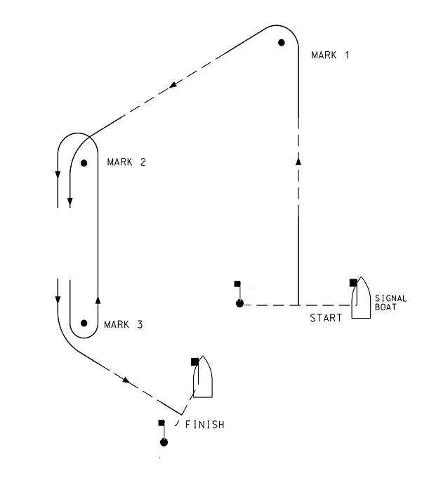

Course Flag: White Flag with course code letters - OUT

Course  Signal | Configuration
OUT | START – 1 – 2 – 3 – 2 – 3 – FINISH (This is the “Standard” course)
OUT 2 | START – 1 – 2 – 3 – 2 – 3 - 2 – 3 – FINISH
OUT 3 | START – 1 – 2 – 3 – 2 – 3 – 2 –3 – 2 – 3 - FINISH
OUT 4 | START – 1 – 2 – 3 – 2 – 3 - 2 – 3 – 2 – 3 - 2 – 3 – FINISH

Appendix – 2

Trapezoidal Course – Inner Loop

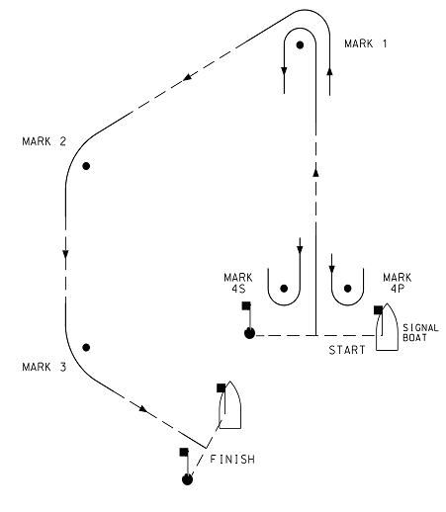
Course: White Flag with course code letters - IN

Course  Signal | Configuration
IN | START – 1 – 4S/4P – 1 – 2 – 3 – FINISH (This is the “Standard” course)
IN 2 | START – 1 – 4S/4P – 1 – 4S/P – 1 – 2 – 3 – FINISH
IN 3 | START – 1 – 4S/4P – 1 – 4S/P – 1 – 4S/P – 1 – 2 – 3 – FINISH
IN 4 | START – 1 – 4S/4P – 1 – 4S/P – 1 – 4S/P – 1 – 4S/P – 1 – 2 – 3 – FINISH

Appendix – 2

Windward/leeward Course

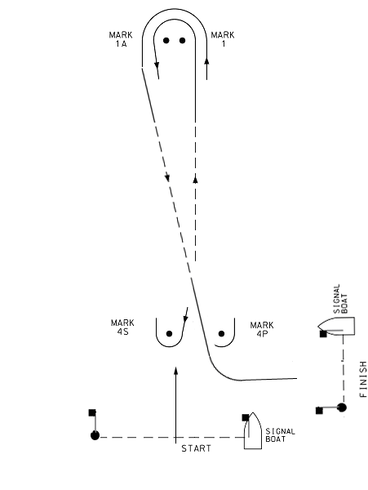
Course: Course: White Flag with course code letters - WIND

Course  Signal | Configuration
WIND 2 | START – 1 – 1A – 4S/4P – 1 – 1A – 4S/4P - FINISH
WIND 3 | START – 1 – 1A – 4S/4P – 1 – 1A – 4S/4P – 1 – 1A – 4S/4P - FINISH
WIND 4 | START – 1 – 1A – 4S/4P – 1 – 1A – 4S/4P – 1 – 1A – 4S/4P 1 – 1A – 4S/4P - FINISH

