The Professional Windsurfers Association together with the Hungarian organizer Kite and Extremesport Association held a press conference. The topic discussed was the PWA Nestea Racing World Cup. This event will take place in Balatonaliga (Club Aliga) from August 31st through to the September 5th.
Present to answer the invitees questions were: Andrew Owen, deputy of the PWA; András Kallós, PR manager of the Coca Cola company; Tamás Merész, Nestea’s brand manager; Péter Tancsa and György Pártos part of the Hungarian organizer Kite and Extremesport Association; and Péter Tusa, director to the Club Aliga, We were very glad to welcome to the conference Micah Buzianis, who is the actual PWA Racing World Champion. Micah is considered the best Formula Windsurfing rider nowadays. Before coming to Hungary, Micah defended his 1st place title in the US Formula Championship held in San Francisco.
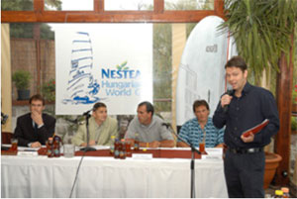
Andrew Owen, the interpreter, Micah Buzianis, Pártos György és Kallós András were answering the questions
The invitees learned that during two days just before the PWA World Cup, Amateur Slalom Races would be held. At this event amateur windsurfers will be able to compete with the world’s best formula windsurfing professionals.
The Nestea PWA Racing World Cup’s planned schedule :
Tuesday, Aug. 31. Amslam – 1st day
Wednesday, Sept. 1. Amslam – 2nd day, Nestea PWA World Cup registration
Thursday, Sept. 2. Nestea PWA Racing World Cup – 1st day
Friday, Sept 3. Nestea PWA Racing World Cup – 2nd day
Saturday, Sept. 4. Nestea PWA Racing World Cup – 3rd day
Sunday, Sept 5. Nestea PWA Racing World Cup - 4th day
During the conference, the invitees asked a lot of interesting questions. We learned from Andrew Owen, that in both the Amslam and the PWA World Cup races the formula windsurfing rules would be determinant. This means, that the PWA organizers will be able to start races if the wind strength is over 7 knots. Also, the maximum width of the boards will be 1005 mm, and the maximum length of the fins will be 70 cm. Moreover, the racers can use sails up to 12,5 m2. Every racer is allowed to use 3 fins, 3 sails, one board, and all the equipment must be production equipment.
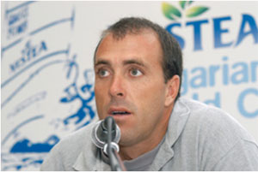
Micah Buzianis: ”I’ll come to Hungary to win again”
Answering the Hungarian online windsurfing magazine’s (Windsurfing.hu) journalist’s question, Micah Buzianis said that he considers Antoine Albeau (FRA 192), Kevin Pritchard (USA 3), Steve Allen (AUS 0) and Wojtek Brzozowsky (POL 10) as his fiercest competition on the water. He comes to Hungary just after the finishing of the world cup in Gran Canaria with his wife and 4-month-old baby boy. Micah would like to prepare to and to familiarize himself with the Hungarian racing conditions. He also would like to spend one day in Budapest to tour the city. He has heard a lot about Bubapest and is looking forward to site seeing.
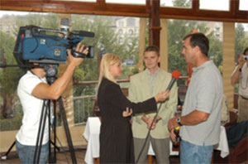
Micah answers the questions of the Hungarian ATV.
Micah let us know that in condition that the International Sailing Association made it possible for professional competitors to apply themselfs for the olimpic games, and among the 11 applicant, it chose the Formula Windsurfing class in Peking - 2008, he would work hard to get a qualification.
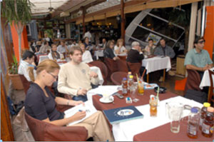
Special attention from media
György Pártos said that thanks to the Nestea, the world’s best windsurfing competitors will come to Hungary for the first time. The Nestea Formula Windsurfing World Cup is as important for Hungarian windsurfing, as the Americas Cup would mean for the hungarian sailing sport if it was organized in Hungary.
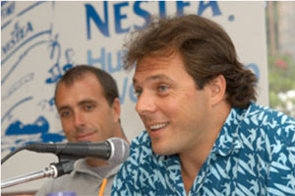
György Pártos – for the first time in the windsurfing history, Hungarian windsurfers will be able to race in a PWA event.
PWA made it possible for Hungarian competitors to compete with the PWA windsurfers during the Hungarian Nestea FW World Cup. We anticipate that the three previous Hungarian Formula Windsurfing champions, Ákos Molnár, Olivér Glofák, György Pártos, and the 2 strongest competitors in the 2004 Hungarian Championships, Gábor Koszti and László Keczéry will compete under the Hungarian flag. There is a possibility that Áron Gádorfvalvi, who races in the Olympic class will be present at the starting line. The best amateur competitors in the Amslam races will get notable prizes. For example, the winner will get a Neil Pryde RS4 10,7 race sail with mast.
Péter Tusa, director of the Club Aliga told us that they would make some improvements in the Club Aliga, even though it was already acknowledged as the best place for organizing previous Hungarian windsurfing events. They will do everything to achieve the highest comfort and security for the competitors.
We hope that the Hungarian racers will do well at the competition, and that Nestea PWA Racing World Cup will return to Hungary in the near future.

