H

P iccolo Hotel

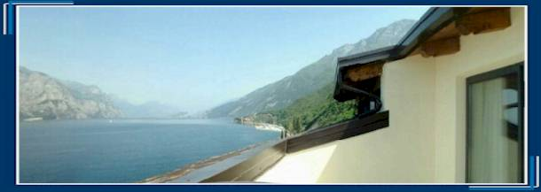

In occasion of the formula windsurfing European championship we propose to our friends the following offer:

European championship special offer

- TRIPLE ROOM : shower, W.C., TV sat, telephone, hair dryer, safe, air conditioned, lake view

€ 76,00 Per day with breakfast buffet

- TRIPLE ROOM : shower, W.C., TV Sat, telephone, hair dryer, safe, air conditioned, without lake view

€ 70,00 Per day with breakfast buffet

- DOUBLEROOM : shower, W.C., TV Sat, telephone, hair dryer, safe, air conditioned, lake view

€ 56,00 Per day with breakfast buffet

- DOUBLEROOM : shower, W.C., TV Sat, telephone, hair dryer, safe, air conditioned, without lake view

€ 52,00 Per day with breakfast buffet

This offer is available from 05/05 to 18/05/04


Via Gardesana, 28 – 37018 MALCESINE (VR) – Tel. 0039 045 7400264 Fax 0039 045 6570488
info@navene.com www.navene.com

